

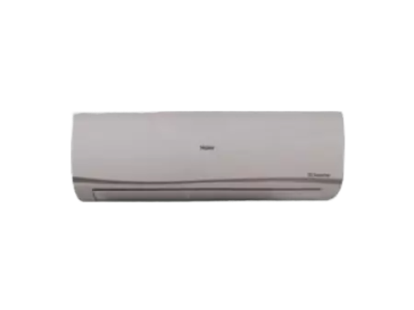

# Haier HSU 18HFTCD T3 1.5

• Capacity (Ton) 1 Ton

• Cooling Capacity (BTU) 19000

• Inverter Yes

• Type Wall Mounted